**FRUIT IMAGE FOR OBJECT DETACTION USING MACHINE LEARNING**

**A PROJECT REPORT**

**Submitted by**

**ARYAN SAMAL -220301120001**

**RASHMI RANJAN NAYAK-220301120009**

**SOUBHAGYAMAYA BEHERA-220301120012**

**SWASTI SWAGAT PALAURI -220301120018**

**In partial fulfilment for the award of the degree** **of**

**BACHELOR OF TECHNOLOGY**

**in**

**COMPUTER SCIENCE ENGINEERING**



**CENTURION UNIVERSITY OF TECHNOLOGY AND MANAGEMENT**

**BHUBANESWAR, ODISHA**

**FEBRUARY 2023-MAY 2023**

**DEPARTMENT OF COMPUTER SCIENCE & ENGINEERING**

**CENTURION UNIVERSITY OF TECHNOLOGY & MANAGEMENT BHUBANESWAR 752050**

**BONAFIDE CERTIFICATE**

Certified that this project report **Fruit Image For Object Detection Using Machine Learning** is the bonafide work of Aryan Samal (220301120001) Rashmi Ranjan Nayak(220301120009) Soubhagyamaya Behera (220301120012) Swasti Swagat Palauri (220301120018) who carried out the project work under my supervision. This is to further certify to the best of my knowledge, that this project has not been carried out earlier in this institute and the university.

**SIGNATURE**

**SWARNA PRABHA JENA**

**Assistant Professor,**

**Department of ECE**

**ACKNOWLEDGEMENTS**

I wish to express my profound and sincere gratitude to **Prof. Swarna Prabha Jena** department of Electronics and Communication Engineering, CUTM, Bhubaneswar who guided us into the intricacies of this project nonchalantly with matchless magnanimity.

We thank **Mr. Rajkumar Mahanta,** head of the Dept. of Computer Science Engineering, CUTM, Bhubaneswar, And **Dr. Sujata Chakravarty,** Dean, SoET CUTM for extending their support during the course of this investigation.

We would be failing in our duty if we don’t acknowledge the cooperation rendered during various stages of image interpretation by **Mrs Swarna Prabha Jena.**

We are highly grateful to **Mrs Swarna Prabha Jena** who evinced keen interest and invaluable support in the progress and successful completion of our project work.

**ARYAN SAMAL -220301120001**

**RASHMI RANJAN NAYAK-220301120009**

**SOUBHAGYAMAYA BEHERA-220301120012**

**SWASTI SWAGAT PALAURI -220301120018**

# Table of Contents

**Chapter 1. INTRODUCTION**

**1.1 What is Fruit Image DDetectio using CNN?**

**1.2 Why CNN used?**

**Chapter 2. LITERATURE REVIEW**

**2.1 Figure 1 (Literature Review on Fruit Image For Object Detection)**

**Chapter 3. METHODOLOGY**

**3.1 Block diagram**

**3.2 Explanation**

**3.3 Dataset**

**3.4 Algorithm**

**Chapter 4.**

**4.1 Model Summary**

**4.2 Model Performance**

**Chapter 5. RESULT & DISCUSSION**

**5.1 Visualisation**

**5.2 Used algorithms Visualisation**

**5.3 Web App interface**

**Chapter 6. CONCLUSION, FUTURE SCOPE REFERENCES &HARDWARE CONFIGURATION**

# CHAPTER 1: INTRODUCTION

## 1.1 What is fruit image detection using CNN?

Fruits are common food consumed by human since prehistoric era. They make important nutritional contribution to human well-being because of their high nutritive value. It is need to ensure the quality of fruits that are consumed in any places. To do this, a fruit detection system can be established that can recognizes various types of fruits from images that are captured by any digital camera or smart phone from various places. This system will help us to check the quality of fruits and also help us to develop a robotic harvesting system from orchards. To develop the system, machine learning techniques have used in this system. Accurate and efficient fruit detection is of critical importance for a machine. A number of factors make fruit detection system a challenging task: Fruits occur in scenes of varying illumination, can be turned off by other objects and are sometimes hard to visually differentiate from the background. An ideal fruit detection system is accurate, can be trained on obtainable data sets, produces its predictions in real time, adapts to different types of various fruits and works using different modalities, such as infrared images and colour images. In recent years, deep learning methods have made important progress in addressing these requirements. Fruit detection can be considered and formulated as an image segmentation problem. The proposed system have used Convolutional Neural Networks (CNN) for detecting fruit information system form images. The proposed method is tried to overcome all the limitations of the related works of fruit detection system and obtain a high accuracy rather than other works.

**1.2** **Why CNN used?**

The system has provided performance with simplicity and efficiency.

• To develop a high-performance fruit detection system that can be quickly trained with a small number of images using a CNN.

• To study the performance of the convolutional neural networks for detecting objects of images. • To know how to build a fruit detection system using machine learning approaches based on convolutional neural networks.

• To improve the detection quality using deep convolutional neural networks compared to support vector machine

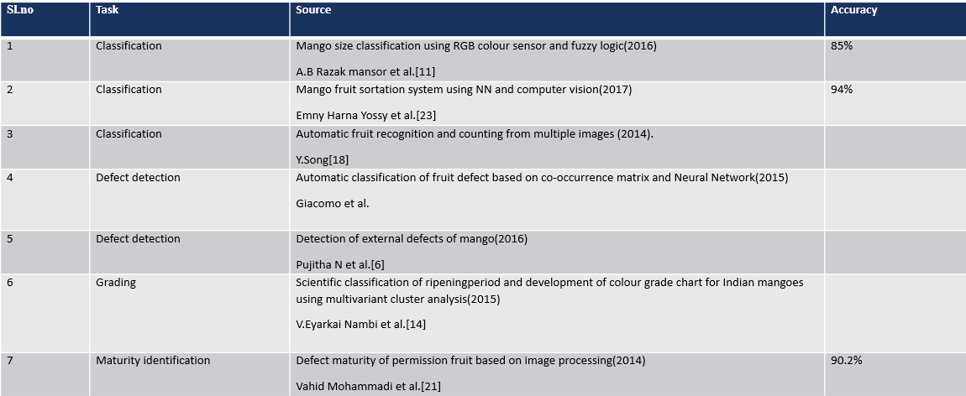**CHAPTER 2: LITERATURE REVIEW**

Fig. 2.1: Literature Review on Fruit Image For Object Detection

As per the literature review the highest accuracy rate is 94 % in fig. 2.1 achieved by the researcher named Emny Harna Yossy on Mango fruit sortation system using NN and computer vision (2017). The draw backs of this project are it takes more time and need to compare with other algorithm.

**CHAPTER 3: METHODOLOGY**

## 3.1 Block Diagram

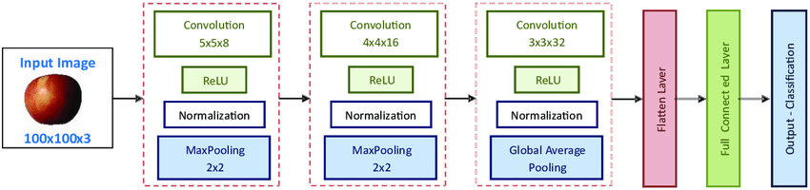

Fig. 3.1 Methodology of machine learning

## 3.2 Explanation

At first, we had collected our image data from Kaggle. Then we processed our data. Then we split our data into training and testing. We train & test data using one algorithm i.e., CNN. Next our model deployment was done. Then we deploy a web app.

## 3.3 Data set

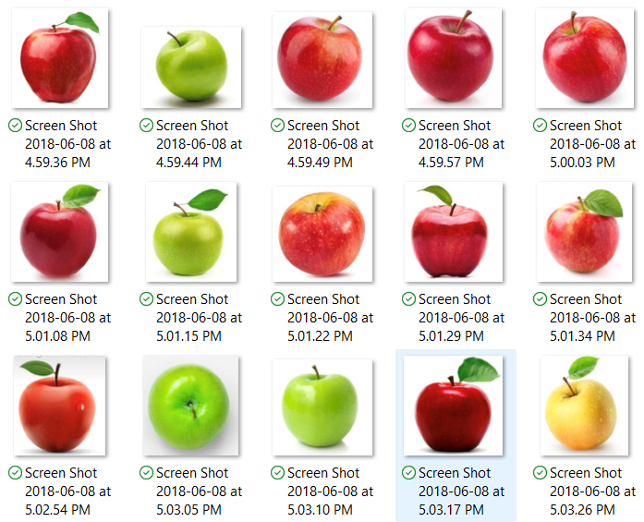

We had taken image type data from Kaggle. It has 1212 images of fruits with labelled name and information and its size is 257 Mb. In this dataset, we took 1212 files of 6 classes. The images were collected from various sources including the internet and pre-processed to align the images and detect them.

**3.4 Algorithms**

***CNN:*** The Convolutional Neural Network (CNN) algorithm is a type of artificial neural network commonly used in image recognition and classification tasks. It is designed to process images in a way that takes into account their spatial structure

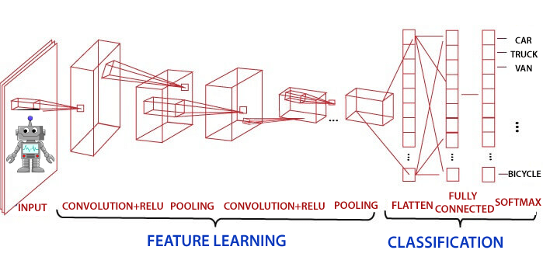

Fig. 3.4.1 Representation of CNN

***Procedure:***

Input image: The CNN algorithm takes an image as input, which is represented as a matrix of pixel values.

Convolution:

The first step in the CNN algorithm is to apply a set of filters or kernels to the input image. Each filter is a small matrix of values that slides over the image, computing the dot product between its values and the values of the image pixels it overlaps with. This process produces a feature map for each filter, which represents the locations in the image where the filter detected a certain feature.

ReLU activation:

The feature maps produced by the convolutional layer are then passed through a Rectified Linear Unit (ReLU) activation function, which applies a non-linear transformation to the feature map. This helps to introduce non-linearity into the model and enables it to learn more complex features.

Pooling:

After the ReLU activation, the feature maps are passed through a pooling layer, which downsamples the feature maps by taking the maximum or average value in each small region of the feature map. This helps to reduce the spatial dimensions of the feature maps and makes the model more computationally efficient.

Overall, the CNN algorithm is a powerful technique for image recognition and classification, and has been used in a wide range of applications, including self-driving cars, medical imaging, and facial recognition.

***Steps in CNN*:** To implement the CNN using Python, we will use the same steps as we have done Below are the steps

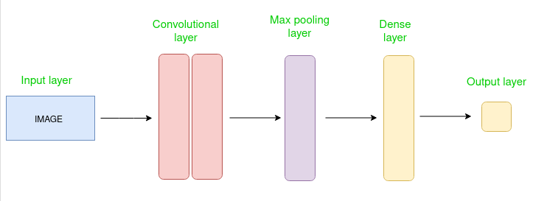

**Chapter 4: MODEL PERFORMANCE**

**4.1 Model Summary**

After training and testing the proposed model, the model can be summarized. The visualization of the model summary is given in figure 4.1.1. The figure also shows the architecture of the proposed model which includes a lot of layers to implement the model. The convolution and max-pooling layers are used in feature extraction part and the dense and soft-max layers are used as the fully connected layer.

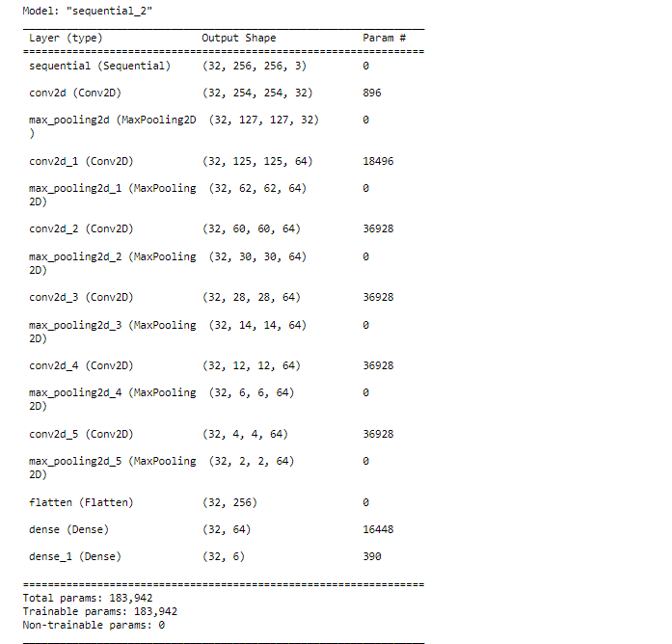

figure 4.1.1 Model Summary

**4.2 Model Performance**

Subsequent to running 20 epochs the proposed model gained the accuracy of 94.64% for the training dataset that was created and 94.89% on the validation dataset. Completing the training session the test on random images went pretty well. The model was able to accomplish a very successive rate. Breaking down the outcome and confusion Matrix it can be assumed that the performance of this model is acceptable for these kinds of fruits. The over-all performance of the model is illustrated in figure 4.1.

In figure 4.2, it indicates the training loss and validation loss of overall model performance. A very plain graph indicates the minimize loss for both training and testing of the model. Figure 4.2 shows the training accuracy and validation accuracy of the overall model performance. So the graph of figure 4.2 is pretty well for both loss and accuracy of training and testing of the model for datasets.

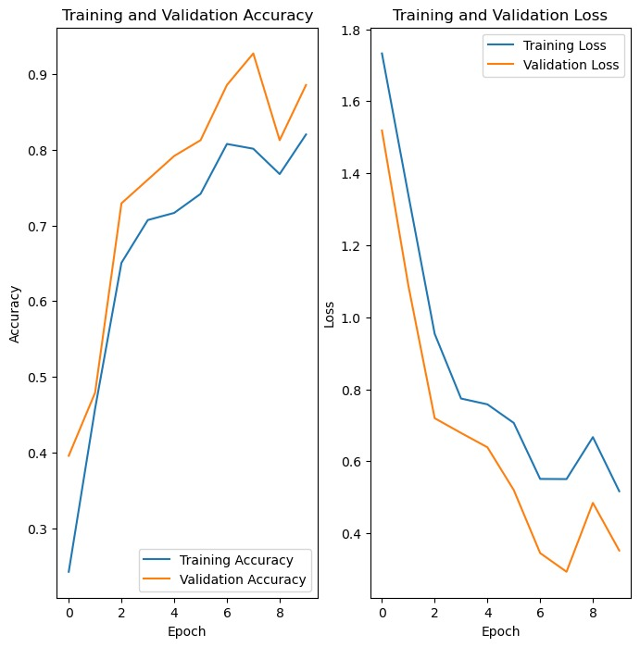

Fig. 4.2 Loss & Accuracy of Training and Validation

# Chapter 5: RESULT &DISCUSSION

## 5.1 Visualisation

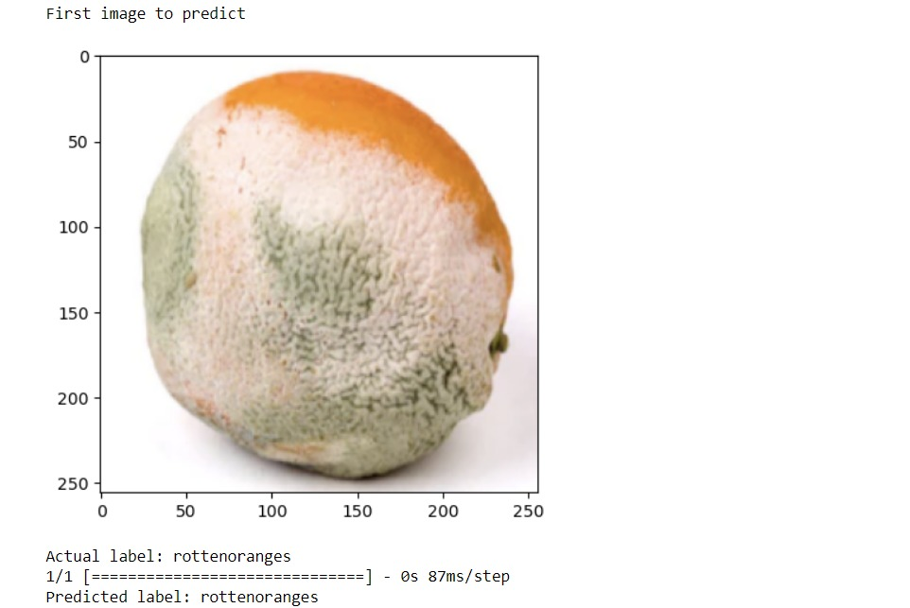

Fig. 5.1.1 First image to Predict

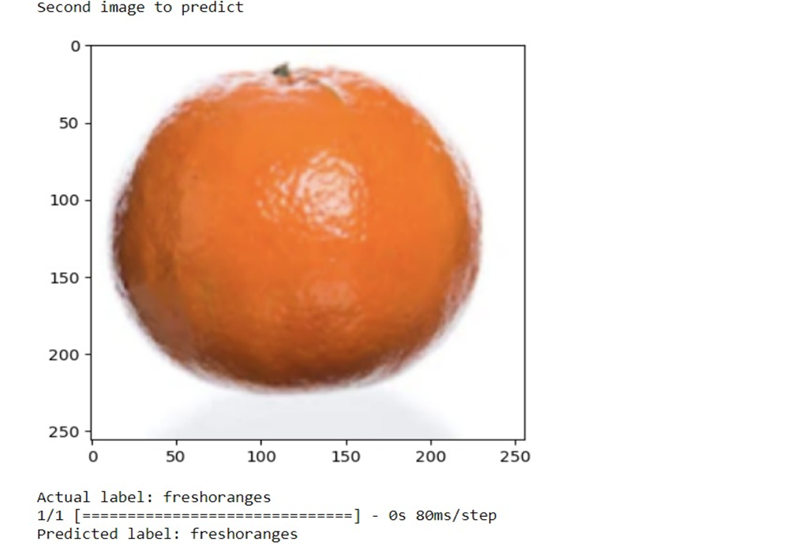

Fig. 5.1.2 Second Image to Predict

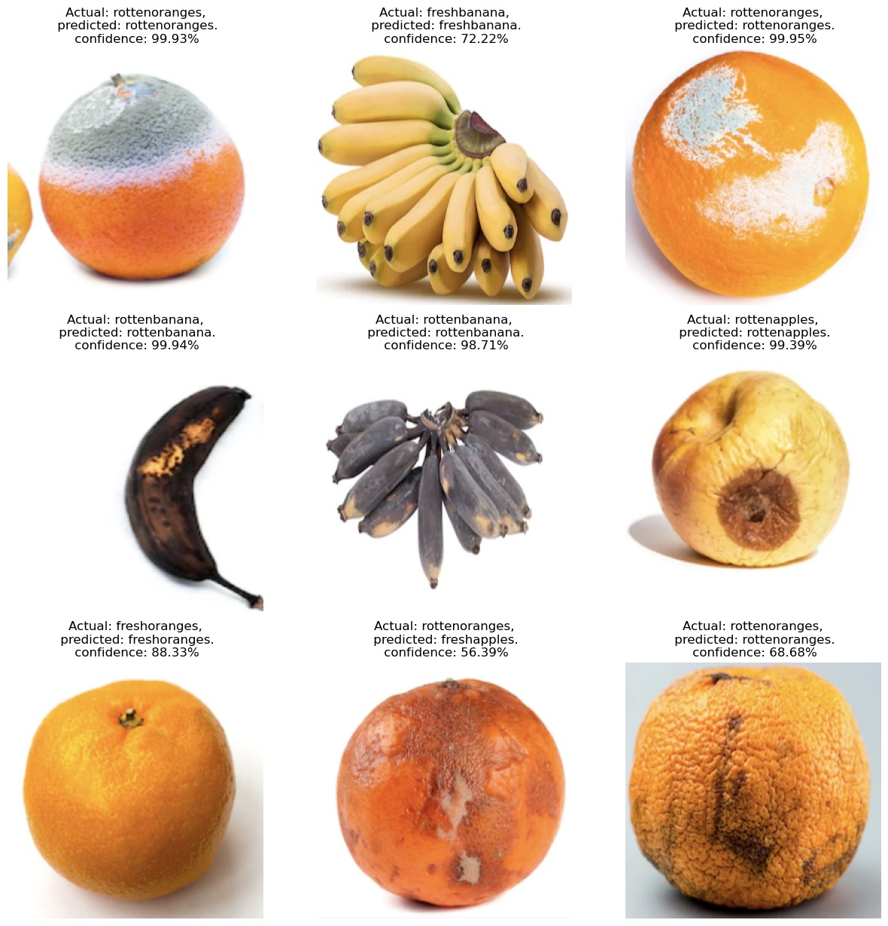

Fig. 5.1.3 Here it is the Multiple fruit detection

**5.2 Used algorithms visualization**

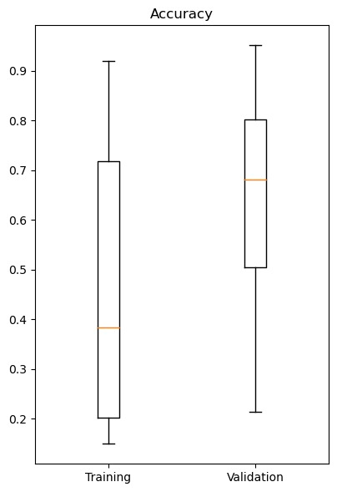

**Fig. 5.2.1 Here it is the accuracy graph**

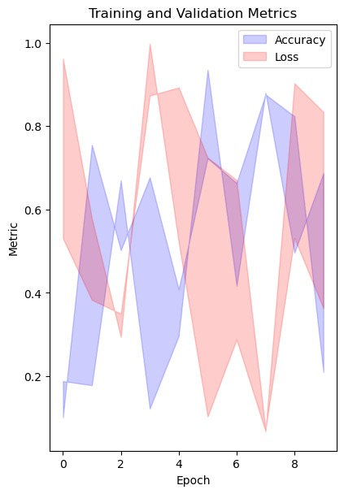

**Fig. 5.2.2 Here it is the training and validation metrics**

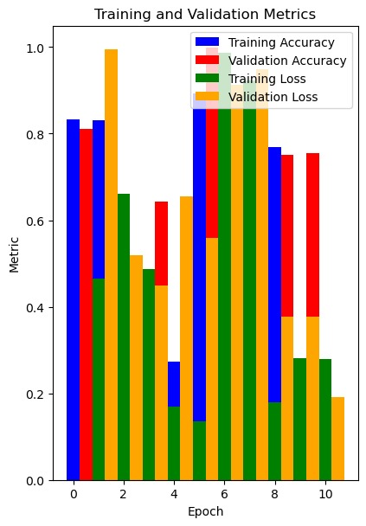

**Fig. 5.2.3 Here it is the training and validation metrics in bar graph**

**5.4 Web app interface:-**

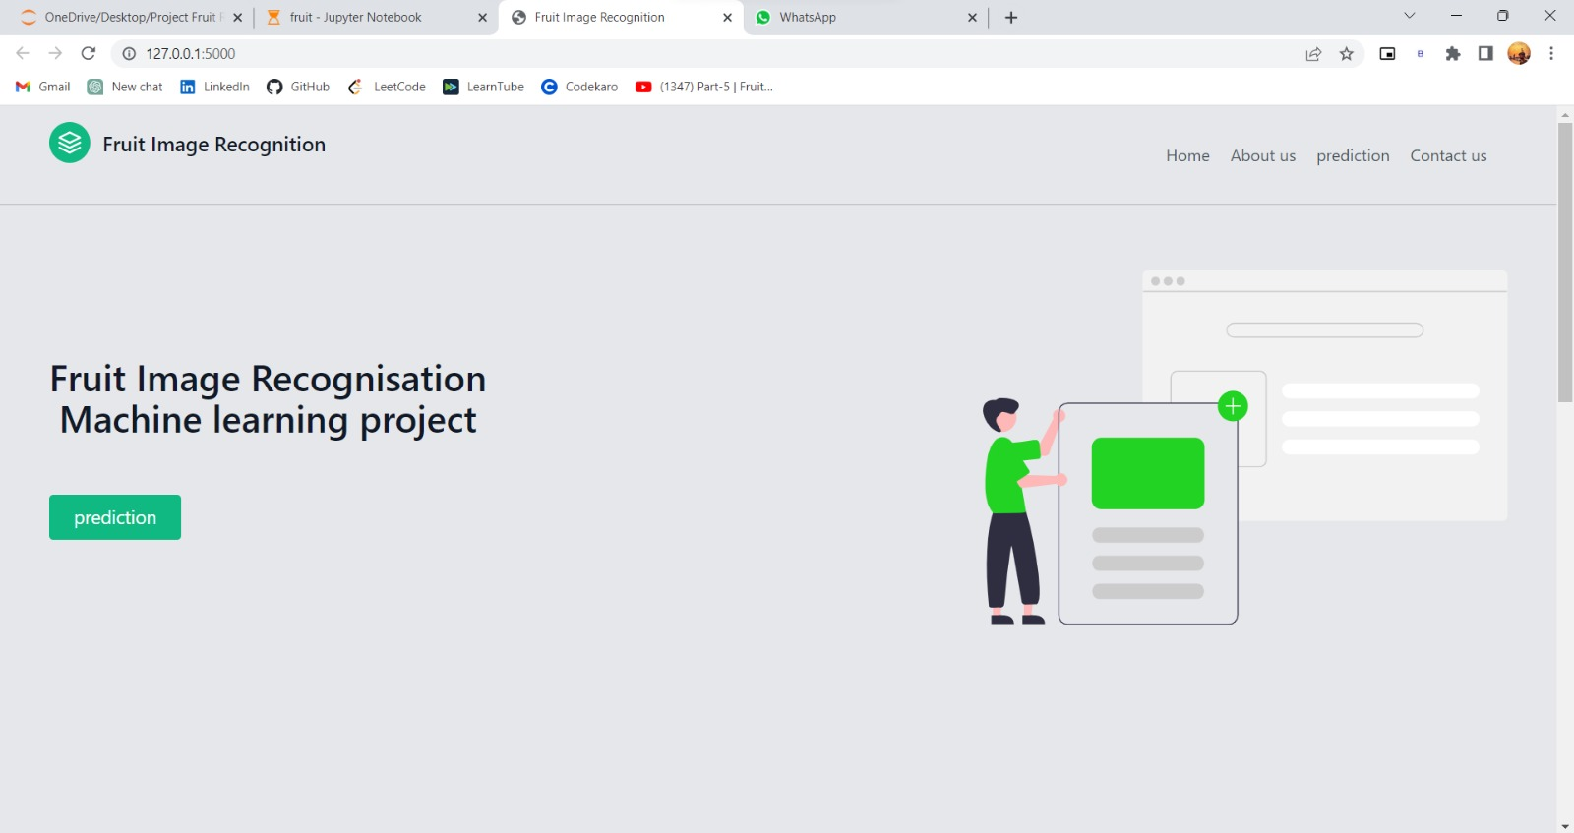Fig. 5.4.1 Website interface

# Chapter 6: Conclusion & Future Scope

**7.1 Conclusions:-**

* The proposed project is able to recognize the fruit.
* This increases the knowledge of common people about some rare and unknown fruits. The project is mainly concentrating on reducing human effort and making human life easier.
* It reduces confusion among the particular fruit.
* Future work that can be added to this project may be the development of a web app. Here the user can use this application anytime anywhere.

**Hardware Configuration**

* CPU: 11th Gen Intel(R) Core(TM) i5-1155G7 @ 2.50GHz
* Installed RAM: 12.0 GB (11.7 GB usable)
* SSD: 512GB NVMe
* Operating system: Windows 11 Home(22H2)
* GPU: Inter(R) Iris Xe (4GB)

**References**

[1] D. Pem and R. Jeewon, “Fruit and vegetable intake: benefits and progress of nutrition education interventions- narrative review article,” Iranian Journal of Public Health, vol. 44, no. 10, pp. 1309–1321, 2015.

[2] R. C. Fierascu, E. Sieniawska, A. Ortan, I. Fierascu, and J. Xiao, “Fruits by-products - a source of valuable active principles. a short review,” Frontiers in Bioengineering and Biotechnology, vol. 8, pp. 319–328, 2020.

[3] S. R. Dubey and A. S. Jalal, “Species and variety detection of fruits and vegetables from images,” International Journal of Applied Pattern Recognition, vol. 1, pp. 108–126, 2013.

[4] R. A. A. Al-Fallujah, “Color, shape, and texture based fruit recognition system,” International Journal of Advanced Research in Computer Engineering & Technology, vol. 5, pp. 2108–2112, 2016.

[5] S. Arivazhagan, S. Newlin, N. Selva, and G. Lakshmanan, “Fruit recognition using color and texture features,” Journal of Emerging Trends in Computing and Information Sciences, vol. 1, no. 2, pp. 90–94, 2010.

[6] P. S. Dutch and K. Jayasimha, “Intra class vegetable recognition system using deep learning,” in Proceedings of the International Conference on Intelligent Computing and Control Systems (ICICCS), pp. 602–606, Maisamaguda, India, June 2020.

[7] A. Nasiri, A. Taheri-Garavand, and Y. D. Zhang, “Image-based deep learning automated sorting of date fruit,” *Postharvest Biology and Technology*, vol. 153, pp. 133–141, 2019.

[8] F. López-García, G. Andreu-García, J. Blasco, N. Aleixos, and J. M. Valiente, “Automatic detection of skin defects in citrus fruits using a multivariate image analysis approach,” *Computers and Electronics in Agriculture*, vol. 71, no. 2, pp. 189–197, 2010.

[9] J. L. Joseph, V. A. Kumar, and S. P. Mathew, *Fruit Classification Using Deep Learning*, Springer, Singapore, vol. 756.

[10] J. M. Ponce, A. Aquino, and J. M. Andújar, “Olive-fruit variety classification by means of image processing and convolutional neural networks,” *IEEE Access*, vol. 7, pp. 147629–147641, 2019.

[11] R. Yamparala, R. Challa, V. Kantharao, and P. S. R. Krishna, “Computerized classification of fruits using convolution neural network,” in *Proceedings of the International Conference on Smart Structures and Systems (ICSSS)*, Chennai, India, July 2020.

[12] S. Lu, Z. Lu, S. Aok, and L. Graham, “Fruit classification based on six layer convolutional neural network,” in *Proceedings of the International Conference on Digital Signal Processing (DSP)*, Shanghai, China, November 2018.

[13] W. C. Seng and S. H. Mirisaee, “A new method for fruits recognition system,” in *Proceedings of the International Conference on Electrical Engineering and Informatics*, pp. 130–134, Selangor, Malaysia, August 2009.

[14] O. O. Abayomi-Alli, R. Damaševičius, S. Misra, and R. Maskeliunas, “Cassava disease recognition from low‐quality images using enhanced data augmentation model and deep learning,” *Expert Systems*, vol. 38, 2021.

[15] A. Almadhor, H. T. Rauf, M. I. U. Lali, R. Damasevicius, B. Alouffi, and A. Alharbi, “AI-driven framework for recognition of guava plant diseases through machine learning from DSLR camera sensor based high resolution imagery,” *Sensors*, vol. 21, no. 11, pp. 3830–3919, 2021.

[16] D. O. Oyewola, E. G. Dada, S. Misra, and R. Damaševičius, “Detecting cassava mosaic disease using a deep residual convolutional neural network with distinct block processing,” *PeerJ Computer Science*, vol. 7, pp. 3522–e415, 2021.

[17] H. Muresan and M. Oltean, “Fruit recognition from images using deep learning,” Tech. Rep., Babes-Bolyai University, Cluj-Napoca, Romania, 2017, Technical Report.

[18] S. K. Behera, A. K. Rath, and P. K. Sethy, “Fruit recognition using support vector machine based on deep features,” *Karbala International Journal of Modern Science*, vol. 6, no. 2, pp. 235–245, 2020.

[19] L. G. Nouaze, J. C. T. Mbouembe, and J. H. Kim, “Yolo-Tomato: a robust algorithm for tomato detection based on YOLOv3,” *Sensors*, vol. 20, 2020.